Unit 15 assignment 2

For the website design, I have decided to choose a dark purple for my main colour for the website since it contrasts well with the white background colour of the website and makes the buttons on the website stand out compared to everything else. The colour for the buttons will also be the same shade of dark purple but go to white with a purple outline for a sense of interactivity when you hover over it. The test will also change colour from white to black to maintain readability. The website will also feature cards with info about the employees as requested by the client. I have also prepared a basic website mockup to give a general idea of the design.

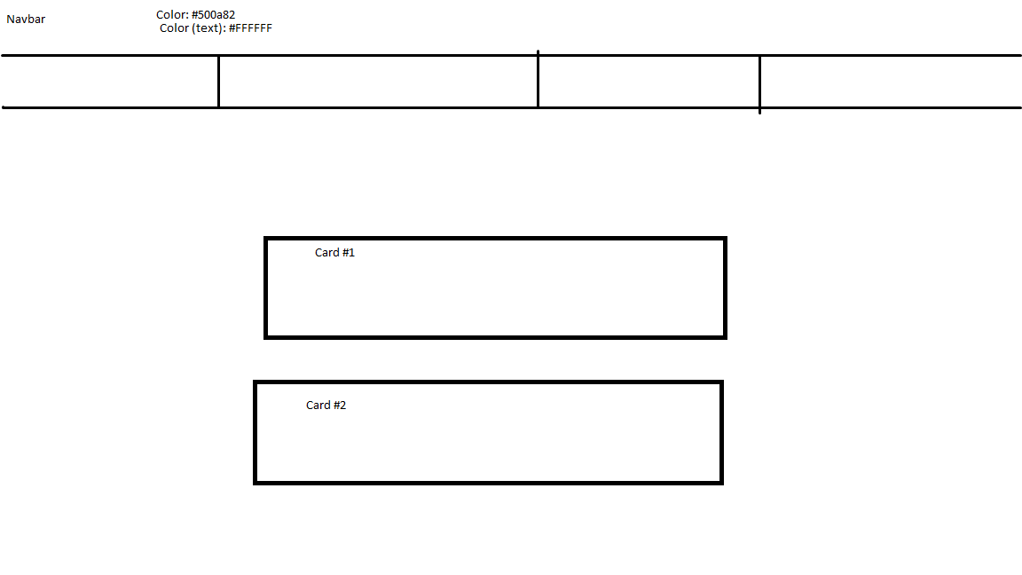

In this mockup, you can see the navbar along with 4 buttons representing the 4 different pages the website consists of. The cards shown in the website design mockup represent the employee profiles of the trainees that currently work in the company.

After reviewing this design with peers, I have decided it would be better to lay out the cards of the employees horizontally across the website instead of vertically. This allows more space for test and effectively utilises all of the available space on the website. In addition to this, I have also decided to include a footer at the bottom of the website for the courses outlined in the client requirements. This allows people to easily find links to the courses if they wish.

Company profile/index:

On the index page of the website, there is a short profile about the company and their values and history. This meets the client’s requirements by giving a general overview of the company to any potential applicants.

Trainee profiles:

On the trainee page of the website, it gives a general overview of what type of existing people we have at the company and their background. This meets the client’s requirements since it has all the information necessary to understand the background of the trainees and helps guide potential applicants to the apply page if they’re interested.

Jobs:

On the jobs page of the website, information about the various positions that are looking to be filled at hot beans are shown. This includes requirements for the position, ant previous work experience (if required at all) and salary information. This fits the client’s requirements as it gives a general breakdown of what is expected at every position and what background experience one would need if they wanted to apply.

Application form:

The job application page of the website has information required to apply for a job at hot beans web. This includes: full name, email address for later contact, what position they’re applying for, why they want to apply, any past experience in the website development field and a place to attach a cv. This meets the client requirements since it gives a simple and straightforward way to apply to hot beans web without any confusing elements. In addition, the full name and email address field are required to prevent any completely blank applications from being sent in.

Testing:

With testing the website, I have decided to undergo manual testing to make sure the website functions as expected (being able to access each part of the website from each page). First of all, I have decided to test if the home page would be accessible from each part of the website (trainees, jobs, applications etc.) and using the evidence below I can confirm that the home page is able to be accessed

Trainees page with before pressing home button on the navbar:

After hovering over the home button :



**As you can see, the website is correctly redirecting me to the index page when pressing the home button on the navbar of the site. This is the expected result.**

**After this, I have decided to test if the apply now from has the correct setup necessary for it to work (requiring a name and email address, an attachment, etc.). the way I tested it is to purposefully fill in the form with missing information to see if it prompts me to fill in the missing fields.**

**Evidence of test:**

**As you can see from the apply now form, it does stop you from submitting the form if you are missing important information (name used as an example here). This is the intended behaviour and is working as expected.**

**Overall, I do believe that the website is fully functional considering my tests of the website’s functionality. In addition to this, the website Is very responsive and loads pages quickly which is an added bonus.**